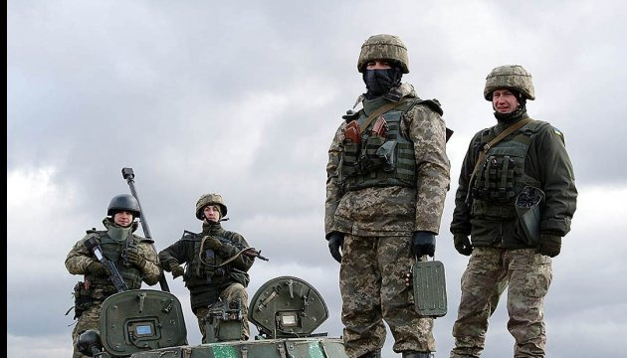

OUR MISSION: HELP UKRAINE

We strive to help held Ukrainian soldiers in need. War struck Ukraine in 2014 after the Euro Maidan Protests. The war on anti-terrorism has been raging on in Eastern Ukraine ever since. Many young men are risking their lives to protect their country. We work on providing them with supplies, humanitarian aid, and rehabilitation equipment. We want to help our soldiers in any way possible and all the help we can get is much appreciated.